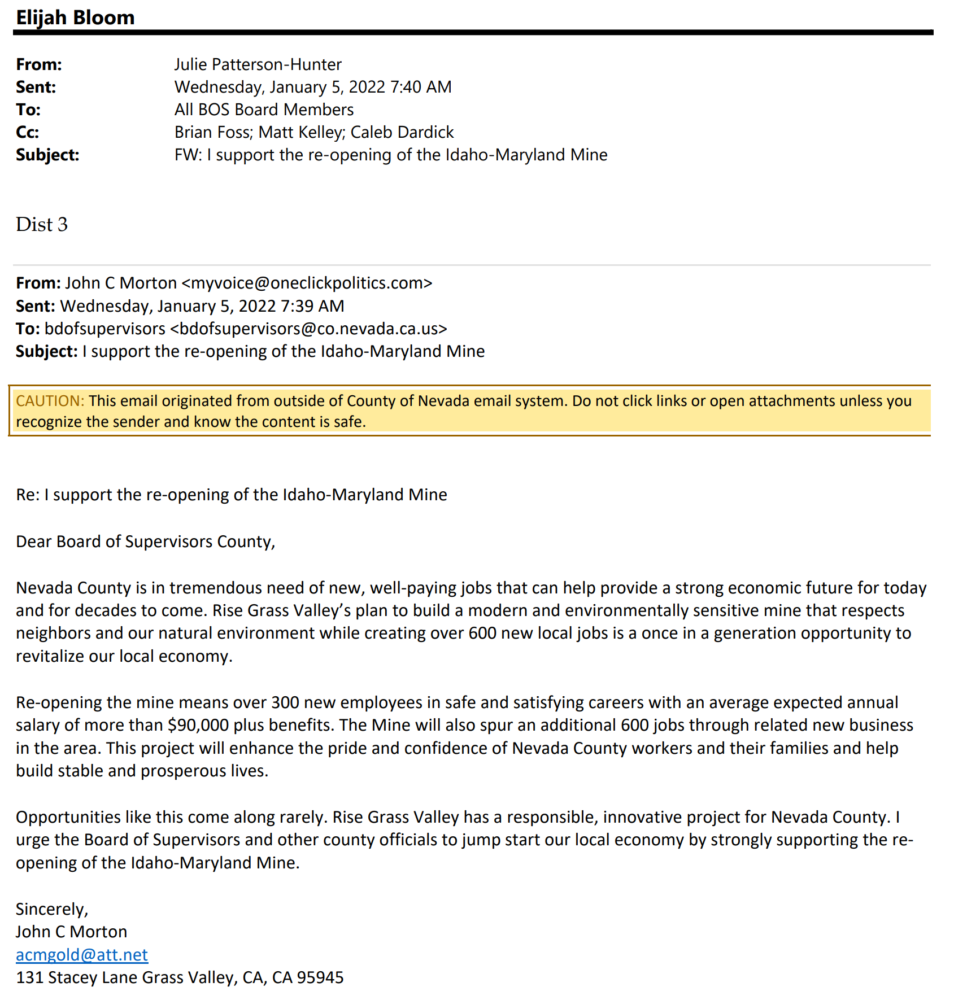
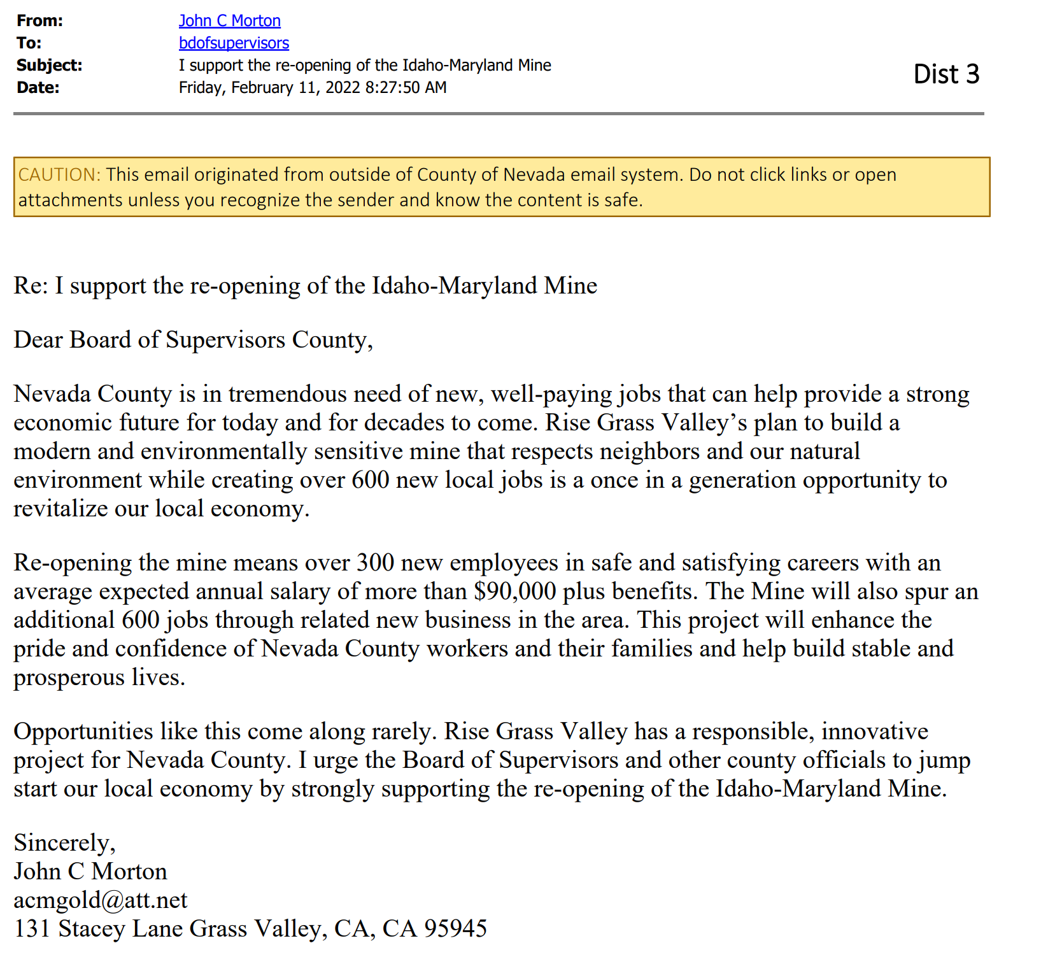
List of the seven entries from John Morton, with the content as those above :
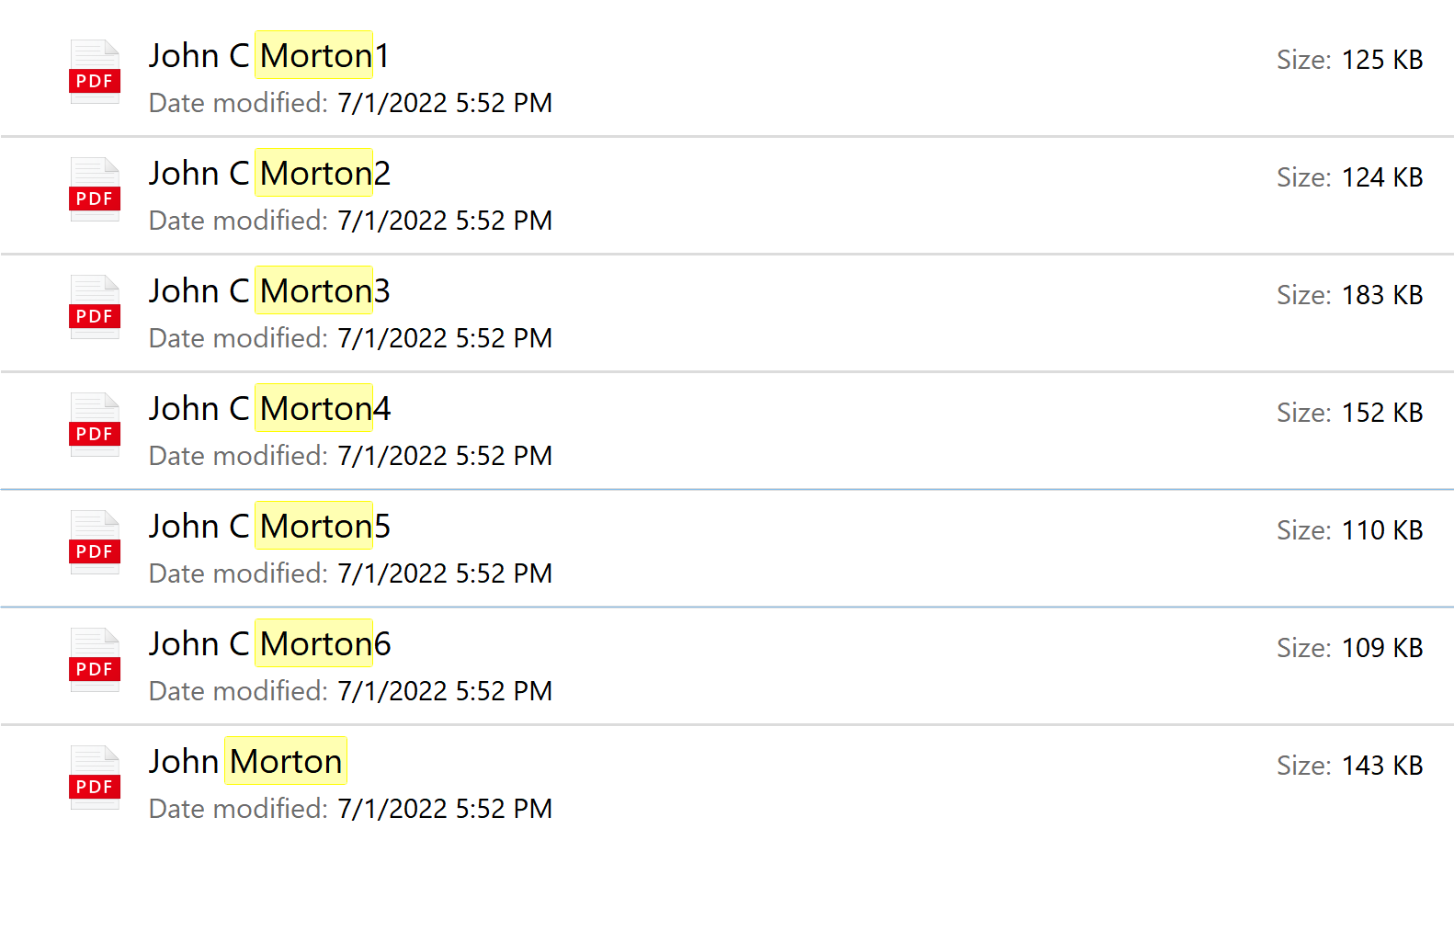
Source: search of “All Draft EIR Comment Letters” : ms:displayname=Search%20Results%20in%20All%20Draft%20EIR%20Comment%20Letters_Clean&crumb=System.Generic.String%3Amorton&crumb=location:D%3A%5CAll%20Draft%20EIR%20Comment%20Letters_Clean

